# System sequnce diagram

The system sequence diagram (SSD) is the artefact which shows inputs and outputs of the system as a black box which means it only describes what system does , no how it does it.

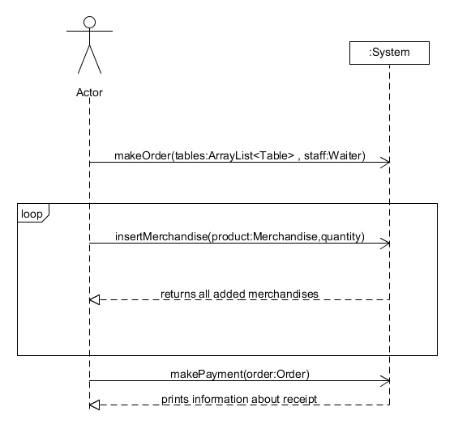

The SSD above was made by following main use case Make Order. Actor makes order in which he specifies tables and who is serving those tables. Afterwards actor inputs merchandises until all of them will be added and system shows all products added already. Afterwards actor makes payment with specified order it also means that order was finished and system prints the receipt.